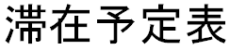
(Schedule of Japan Stay)
August 10th, 2019

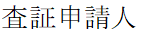 Dr. <Your Name> 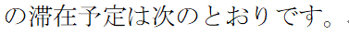

Date | Schedule | Contact | Accomodation
2019/10/14 | XXX Airport to Kansai Airport (Flight number: XXX-XXX) |  | Your Accommodation Information
2019/10/15  ～  2019/10/18 | Participation of IEEE GCCE 2019 | Venue of IEEE GCCE 2019  Senri Life Science Center  (1-4-2 Shin-senri-Higashimachi, Toyonaka, Osaka 560-0082, Japan)  Tel: +81-6-6873-2010
2019/10/19 | Kansai Airport to XXX Airport (Flight number: XXX-XXX)
_

